**Project Title:** **Customer Relationship Management Sales Opportunities Analysis using SQL Server Management Studio (SSMS) and Excel**

Customer Relationship Management (CRM) is a strategy companies use to manage interactions with customers and potential customers. It helps organizations streamline processes, build customer relationships, increase sales, improve customer service, and increase profitability.

CRM records customer information, organizes the information to give a complete record of individuals and companies, so one can better understand the relationship over time.

A Sales Opportunity is a qualified prospect who is highly likely to become a customer. Identifying opportunities allows sales managers to focus their resources more effectively.

**Introduction**

Forging good relationships and keeping track of prospects and customers is crucial for customer acquisition and retention, which is the main purpose of CRM. Everything is placed in a simple, customizable dashboard that can tell a customer’s previous history, the status of their orders, any outstanding deals, and more.

This dataset provides information on the prospective accounts(companies), Products, Sales team and the Sales Pipeline of a Hypothetical company. We can track meetings with companies, record of the deal stage and close value. The sales manager can access reliable information about the progress of individual team members in achieving their sales target, assess deal viability which enables them manage sales pipeline and all individual milestones from gaining the interest of potential customers through to closing a deal or otherwise and provide teams with real-time update. Sales Reps also get a deeper understanding of their clients, and the opportunity to spend more time developing the best strategy required to close a deal.

This project is a Sales Opportunity analysis, in which we aim to analyze the dataset to gain deeper insights on valuable information that can guide the company on decision-making, in order to improve the efficiency of their sales strategy and have their products in as many sectors as possible with exponential revenue growth.

**Problem Statement**

The company is currently encountering a number of substantial obstacles in introducing their products into certain sectors of the market, such as enhancing sales channels to increase revenue, pinpointing underperforming products, sectors and accounts that may require attention or discontinuation of a deal, and assessing sales team performance to identify regions and Sales Reps with high or low sales.

**Data Overview**

The CRM dataset consists of 4 tables that cover various aspects of the company’s operations including:

1. **Accounts:** Record of the accounts, giving details on the company name, the sector they belong to, the year of establishment, size of the company, location, parent company (if any), and the annual revenue in millions of USD.
2. **Products:** Details about the product name, the series each one belongs to and the suggested retail price.
3. **Sales Team:**  Contains detailed information about the sales team, including the name of Sales Agents, their respective Sales Manager, the regional office where they work.
4. **Sales Pipeline:** Comprehensive details about deals in the company. Each deal as a unique identifier which is the opportunity id, the name of the sales agent in charge of the deal, the product to be sold, the company with which negotiations are being made, the deal stage (whether it has been won/lost, still in prospect or the deal is currently ongoing), the close date (i.e., when the deal was won/lost), and the revenue made from the deal.

**Data Transformation**

The dataset was imported as a flat file into Microsoft SQL Server Management Studio (SSMS) and data cleaning and transformation was done to prepare the data for exploration and modeling. The data transformation steps were performed by using SQL statements and they include:

1. **Removal of Duplicates:** This was done by setting row numbers and using a subquery to pick out the rows where the row number was greater than 1. In this dataset, no duplicate was found.
2. **Data Standardization:** This helps to eliminate redundancies, errors and inconsistencies, resulting in higher data quality. The first step in this process was the removal of spaces using the TRIM function. After which, the data types in some of the columns were changed to the proper format. Also, a spell check was done and the UPDATE function was used to effect the necessary changes.
3. **Ensuring Data Integrity:** The relationship between tables in the dataset was validated and the integrity concerns about the references were rectified to ensure the validity of the dataset.

**Data Modeling**

A relational diagram or database diagram was used to show the tables and their relationships in the data. It gives a granular view of the database, including tables, columns and relationships. A relational diagram was used in place of an Entity Relationship Diagram (ERD) because the former adheres to the standards set, ensuring consistency.



**Relationships:**

* **Sales pipeline** Table to **Product** Table: via **Product** Column.
* **Sales pipeline** Table to **Accounts** Table: via **Account** Column.
* **Sales pipeline** Table to **Sales teams** Table: via **Sales agent** Column.

**Exploratory Data Analysis**

Prior to conducting any analysis on a dataset, it is important to do an EDA in order to determine how best to manipulate data to get the answers needed.

Exploratory Data Analysis (EDA) helps us to gain better understanding of our data and identify patterns, relationships, and outliers that might not be immediately obvious. By doing this, we get familiar with the data, are able to “see the bigger picture”, and make more informed decisions when analyzing the data.

**Key Performance Indicators (KPIs)**

KPIs were added to tell us how well the products, the company and its customers are faring. In this analysis, performance based on this key metrics were noted:

* **Total Customers:**  The company serves a customer base of 85 accounts in 10 different sectors.
* **Revenue:** The company achieved a total of $10,005,534 with the average monthly revenue being $6108.38
* **Net Profit:** The company generated a net profit **-**$17948.
* **Total Sales Agents:** The company had a total of 35 sales agents but only 30 were active. The sales agents were distributed across each regional office thus; 11 in the central region, 12 in the East region and 12 in the West region.
* **Total Opportunities:** The total number of deals brought in by sales agents were 8800, including the Prospecting, Engaging, Won, and Lost deals.
* **Total Products:** The company offers a total of 7 unique products which are grouped into 3 series.
* **Order Quantity:** Customers ordered a total quantity of 4238 products.
* **%Conversion:** The rate at which Agents were able to take a deal’s status from “Prospecting” to “Engaging” expressed in percentage is 5.57%.
* **%Win:** The rate at which the agents were able to take a deal’s status from “Engaging to Won” expressed as a percentage of the total deals is 14.61%.
* **%Loss:** The number of lost deals expressed as a percentage of the total deals is 8.42%.
* **Average Sales Cycle:** The average number of days it took to change a deal’s status is 47days.

**Customer Analysis Report**

This report provides a detailed analysis of the company’s performance from the customer perspective (i.e., the accounts registered with them). The analysis gives insights into the revenue generated by each company, Top 10 customers by close value on deals, Number of Customers in each Region, Number of products bought by Customers, Number of Won deals, thriving sectors based on order quantity, number of won deals, and close value.

**Top 10 Customers by the Company’s Annual Revenue**

The revenue generated by each individual company annually helps us to know the financial standpoint of such customer. It will not be ideal to be in business with a company at the brink of bankruptcy.

The top customer, Kan-code, generates an exceptionally high amount of revenue annually ($11.6 million) which outweighs the income of other companies like Hottechi, with an annual income of $8.1 million. This indicates the company’s sales agents should look out for such accounts as prospecting customers for the products.

**Top 10 Customers by Average Close Value**

The average close value is a better representation of the strength of a customer because it shows their best capacity over a period of time and many deals.

The top customer according to this analysis is Cheers ($2200), followed by Xx-holding ($2143), Goodsilron ($2074), Labdrill ($1973), Mathtouch ($2016).

This trend is completely different when we consider the close value as we have the customer with the highest close value being Kan-code ($341455), followed by Konex ($269245), Condax ($206410), before getting to Cheers ($198020).

**Net Profit and Order Quantity**

The performance of customers based on their order quantity and the count of won deals had a unique trend amongst the following customers.

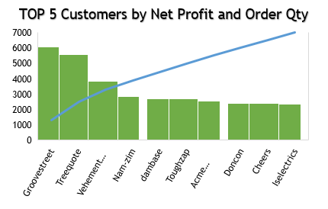

The customer with the highest net profit is Groovestreet ($6076) with 35 orders. The customer that had the highest order quantity is Kan-code with 115 orders but, made a net profit of -$3032. The retail sector had the highest sum of close value for deals ($1,867,528) and the highest order quantity (1397)

**Opportunities**

This is the deal count or opportunity we got with each customer per time.

The customer with the highest number of won deals is Kan-code (115) and lost the highest number of deals (82) to Hottechi, which happens to be the customer with the second highest count of won deals.

**Sales Agents Analysis Report**

This report provides a detailed analysis of the sales agents’ performance and their contribution to the company. The analysis gives insights into the total revenue generated by the sales agent, Top 10 sales agents based on the revenue made from deals, Top 10 agents based on the deals/ accounts they were able to pull in, Close Value of sales agents by region, Win rate and conversion rate of sales agents. It also highlights the best and worst sales agent based on their revenue, the regional office and manager in charge of them.

**Number of Sales Agents:** The company has a total of 35 sales agents but, only 30 are active.

**Top 10 by Revenue:**

The sales agent that made the highest revenue from the close value of deals is Darcel Schlecht ($1,153,214), followed by Vicki Laflamme ($478,396). The least revenue from the close value of deals was made by Violet Mclelland ($123,431).

**Top 10 by Count of deals:**

The sales agents that brought in the highest number of prospects is Darcel Schlecht (747 deals) and he was able to win 349 of these deals.

**Top 5 by Average Revenue:**

The sales agent with the highest average revenue is Elease Gluck ($43,041).

**Conversion Rate and Win Rate**

The conversion rate is calculated by the Number of engaging deals ÷ Total count of opportunity. The agent with the best conversion rate is Rosalina Dieter (0.31).

The win rate is calculated by the Number of Won deals ÷ Total count of opportunity.

The agent with the best win rate is Reed Clapper (0.65).

**Product Performance**

This report provides a detailed analysis of the performance of products in the market from the customer’s perspective (i.e., the accounts registered with them). The analysis gives insights into the performance of products based on the revenue generated, order quantity for each product, Monthly revenue growth on products, Units of products sold over time, Revenue made from products in each region.

**Product performance by revenue generated**

**Revenue growth on products over time**

There was a significant decline in the amount of revenue generated in April, July and October, with July having the least amount of revenue. June is the month with the highest revenue ($1.3 million) and it happens to be the month where we had most sales (531 units).

**Product with highest revenue**

**Details of Product with the Highest Revenue**

GTX Pro

GTX Series

Revenue

$3.5M

Average Close Value

$4,851.611.61erage Close Value

$4851.61

Retail Price

$4,821

Prospects

1,480

Order Quantity

729

Net Profit

-$3931

GTX Pro, belonging to the GTX series, is the highest revenue-generating product, bringing in $3.5 million. Despite having a high retail price of $4,821, it has been ranked as the 3rd highest selling product which indicates a strong demand and market acceptance. With a total of 1480 prospects and 729 won deals, this product significantly contributes to the company’s net profit, totaling -$3,931.

**Most Sold Product**

**Details of Most Sold Product**

GTX Basic

GTX Series

Revenue

$449,263

Average Close Value

$5451.61erage Close Value

$4851.61

Retail Price

$550

Prospects

1,866

Order Quantity

915

Net Profit

-$3987

GTX Basic, belonging to the GTX series, had an order quantity of 915 units, making it the highest sold product. Despite having a relatively low retail price of $550, it has generated significant revenue of $499,263. With a total of 1866 prospects, this product significantly contributes to the company’s net profit, totaling -$3987.

**Opportunity Trend**

This report provides a detailed analysis of the opportunities brought in by the sales agents. The analysis gives insights into the total count of opportunities including the Prospecting, Engaging, Won, and Lost deals, trend of opportunities over time. The interval between the time it takes to engage an account and the time it takes to win/lose a deal gives us the average sale cycle.

The total opportunity brought in by the sales agents is 8800, with 500 prospecting deals, 1580 engaging, 4238 won, and 2473 lost deals.

**Monthly Trend**

The Monthly trend shows a significant peak in July, 2017 (1198 prospects), and this trend is followed for each deal segment monthly.

**Time interval**

The average number of days taken to win a deal was 51 days, while the average time it took to lose a deal was 41 days. The overall average time interval was 47days.

**Region Performance Analysis**

The regional office in the Central region had the highest order quantity (1629 units) while the highest revenue was generated by the West region ($3.5 million).

**Insights and Findings**

The sales opportunity analysis for this company reveals valuable insights into their business performance. From the customers’ perspective, Kan-code, Hottechi, Konex, Xx-holding and Initech stand out because of the amount of revenue they are able to generate annually, indicating their significant purchasing power. To further check for the purchasing power, the close value for each company was analyzed and this revealed that Kan-code and Konex indeed have a great purchasing power and they are closely followed by Condax and Cheers. The top customer, Kan-code, stands out with a close value of $341,455, and an average close value of $1825.

On the product side, GTX Pro, belonging to the GTX series, emerges as the highest revenue-generating product, bringing in $3.5 million. Despite having a high retail price of $4,821, it has been ranked as the 3rd highest selling product which indicates a strong demand and market acceptance. With a total of 1480 prospects and 729 won deals, this product significantly contributes to the company’s net profit, totaling -$3,931. GTX Basic, belonging to the GTX series, had an order quantity of 915 units, making it the highest sold product. Despite having a relatively low retail price of $550, it has generated significant revenue of $499,263. With a total of 1866 prospects, this product significantly contributes to the company’s net profit, totaling -$3987.

Sales are booming in the Central region with 1629 units sold, contributing $3.3 million in revenue, and the highest revenue is being generated from the West region ($3.5 million).

For the sales agents, Darcel Schlecht was the highest revenue generator as the amount made from the closed deals gave a total of $1,153,214, followed by Vicki Laflamme ($478,396). The highest number of deals were also brought in by the same Darcel Schlecht.

**Recommendations**

Based on the analysis of the CRM Sales Opportunity for this company, the following strategic recommendations are proposed to capitalize on strengths and address opportunities for improvement:

1. Managers are to set weekly/monthly/quarterly goals for the sales agents under them, and provide incentives for the sales agents doing well and those who maintain consistent performance should be promoted. This will foster a healthy competitive environment and help the sales agents to focus on reaching the set goals per time. A staff appraisal can be organized intermittently to enable frequent communication with the sales agents. This way, sales agents are able to bear their minds about how they feel about their jobs, the challenges they might be facing, and other issues. In the event of the inability of some sales agents to express themselves openly, a suggestion box can be created, all of these will improve the efficiency of sales agents and sales strategies.
2. The various regional offices should be provided with adequate resources to enable proper functioning of the staff. Training and development programs can be organized to enlighten the sales agents on effective methods needed to formulate a sales strategy. The managers can also provide opportunities, create extra responsibilities for the sales agents to expand their experience and put them in better stead for promotions.
3. Implement a customer retention strategy that will help to gain the loyalty of customers. This can include assigning a dedicated customer service team to each customer, offering competitive pricing, carrying out customer satisfaction surveys regularly, etc.
4. For products which are not thriving on the market due to low order quantity or a high count of lost opportunities (churn rate), the customer service team can conduct a survey to help identify the root cause of churn, look for patterns in the churn customers, determine the reasons for churn from these surveys. We can also pay attention to pricing in some cases.

**Images from the dashboard**

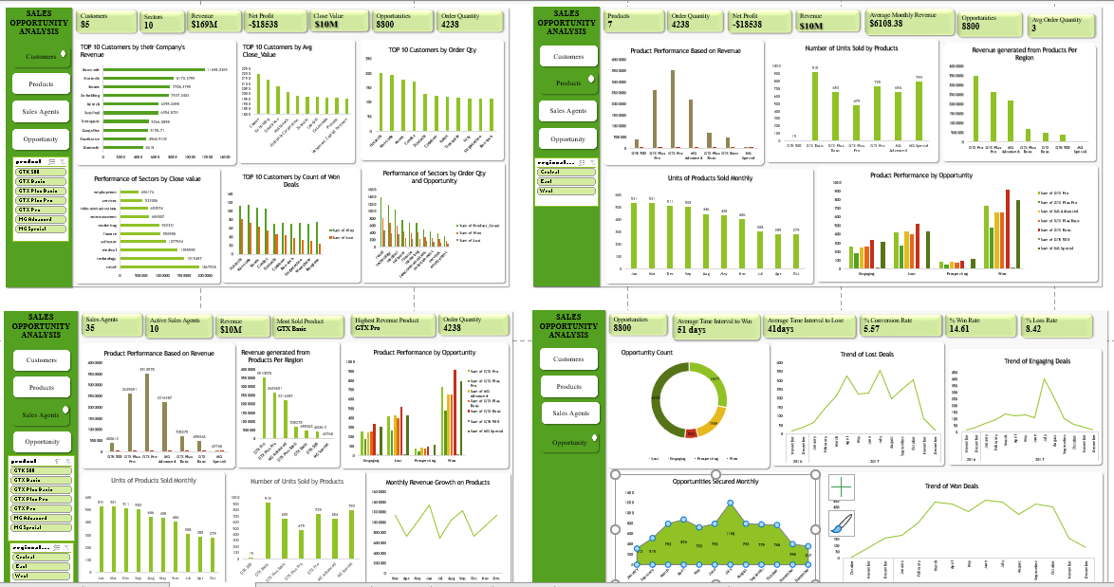

**Conclusion**

By implementing these strategic recommendations, the company can optimize its sales opportunities, enhance customer satisfaction, and drive sustainable revenue growth.

Continual monitoring of the churn rate and customer behavior will be crucial in adopting strategies to maintain relevance and foster competition in all sectors of the market.